Assignment 2 Guidance

# Task 1 – Peer Review and Feedback Analysis (P4 – M3)

You will have to:

* Create a formal questionnaire that effectively reviews your business application, problem definition statement, proposed solution and development strategy.
* Use this questionnaire as part of a peer-review and document any feedback given
* Interpret your peer-review feedback and identify opportunities not previously considered
* Evaluate any new insights, ideas or potential improvements to your system and justify the reasons why you have chosen to include (or not to include) them as part of this business application.

# Task 2 – Application Development (P5 – M4)

You will have to use selected tools, techniques and technologies to develop a functional business application based on SRS in the previous assignment.

### General Requirements

You can choose suitable programming language and MVC web framework to implement the application

* **The application MUST implement at least 1 use-case completely**
* **The application MUST have the entity models which includes several entities**
* **The application MUST have at least 2 controllers**
* The application **SHOULD** have the feature to extract report
* You have to additionally use **HTML5, CSS3** to create the content and to stylize your web application
* You may optionally use **JavaScript, jQuery, Bootstrap, Ajax**

### Forbidden Techniques and Tools

* Using CMS / blog systems (like WordPress, Drupal and Joomla) is forbidden.

### User source control system

* **Use GitHub** or other source control systemas project collaboration platform and commit your work
* Submit a link to your source code repository in the report
  + The repository must be **private** and **is accessible** to the Assessor / Lecturer during the Presentation / Demonstration.
* You should have commits in at least 3 DIFFERENT days
* You should have at least 10 commits

### Deployment

* You can use localhost for deployment
* Use suitable service to deploy your application (IIS Local Server, Azure, Heroku, AWS, GCP, etc.)
* Submit a link of your deployment.

Then, you will have to include evidences that the system has been developed successfully (images, sample source code, GitHub repository, folder structure, result of the deployment etc.)

# Task 3 – Application Evaluation (P6 – M5 – D2 - D3)

For this part, you will have to:

* Your implementation, is it subjected to the selected use-case? Explain.
* Issues that you have had during implementation? Explain. How you solved these issues?
* (Optional) Critically evaluate the strengths and weaknesses of your business application and fully justify opportunities for improvement and further development.

Report Structure

# Chapter 1 – Peer Review and Feedback Analysis

1. Formal questionnaire to reviews the business application, problem definition statement, proposed solution and development strategy
2. Collect review feedbacks
3. Interpret peer-review feedbacks
4. Evaluate any new insights, ideas or potential improvements

# Chapter 2 – Application Development

1. Folder structure of the application

Bin folder: This folder contains debug folder

Identity folder: This folder contains the Identity account

Controllers folder: This folder contains code files that handle requests from the user and generate responses. Examples such as Book Controller, Publisher Controller,and the like

Models folder: This folder contains code files that define the data models used by the application. For example like Book, Author, Publisher, etc

Views folder: This folder contains code files that generate HTML pages to be displayed to the user. Examples such as Authors, Home, Books, and the like

Data folder: Data refers to the information stored in the application's database or other storage medium such as migration, AppklicationDbContext.

Migration is used to apply changes to the database schema.

Wwwroot contains css, images, js, lib, ..

1. **MAIN** Source code samples of the application with **explanation**
2. Screenshots of the application
3. (Optional) Screenshots of using GitHub or GitLab to manage the source code
4. (Optional) Screenshots of using IIS or Azure for the application deployment

# Chapter 3 – Application Evaluation

* Your implementation, is it subjected to the selected use-case? Explain.

The application complies with the given cases:

Regarding login, the app has 2 roles: customer and admin. Especially when the Customer is not registered but logs in, the app will redirect to the registration form for the Customer to register. About the admin account, when you log in, you will go to the dashboard and can manage the book, author, and publisher of the app.

As for CRUD, the App also provides all the above functions (Add, Read, Update, Delete) for each object such as Book, Publisher, and Author.

* Issues that you have had during implementation? Explain. How you solved these issues?

**Image rendering problem**

Method 1: We handle it by placing the image in the image file located in the wwwroot folder so that it references the HTML to render the image we add.

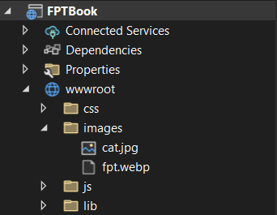

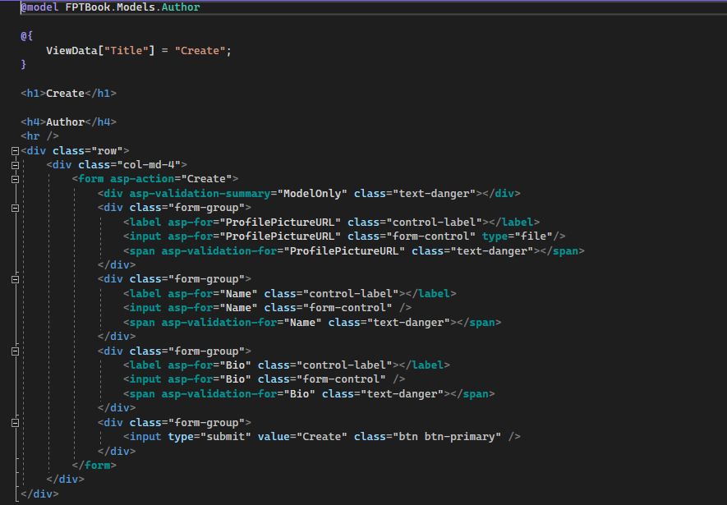

Method 2: Set the id for the image then use the DOM to get the image

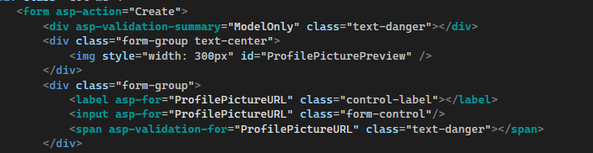

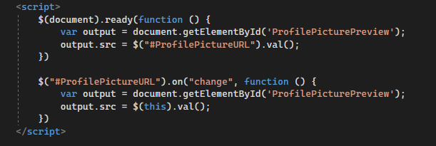

**Database update problem**

We have to delete the existing migration and database to re-render the database to get the table book and table publisher

